NOAKHALI SCIENCE AND TECHNOLOGY UNIVERSITY



**Project Proposal on Web Engineering**

**Project Title :** Online Education Website

**Course Code:** CSTE 3206

|  |  |
| --- | --- |
| **Submitted by:**  **Name :** Safwan Ishrak  **Roll :** ASH2001029M  **Session :** 2019-2020  **Name :** Md. Kutub Uddin Abir  **Roll :** MUH2001009M  **Session :** 2019-2020  **Name :** Farman Arefin Tamim  **Roll :** ASH2001043M  **Session :** 2019-2020 | **Submitted to:**  **Ratnadip Kuri**  Assistant Professor  Department of Computer Science and Telecommunication Engineering.  Noakhali Science and Technology University. |

**Submission Date : 27 November 2023**

**Abstract**

Our online education platform streamlines education with roles for admins, teachers, and students. Admins manage users, log trails, and system data. Teachers create classes, upload materials, and communicate. Students sign up, engage with quizzes, download materials, and connect with peers and teachers, fostering a collaborative and efficient virtual learning environment.

**Motivations:**

* **Empowering Education Accessibility**
* **Efficient User Management**
* **Transparency through Log Trails**
* **Empowering Educators**
* **Interactive Learning Environment**
* **Flexibility for Students**

**Major Features:**

* Admin, Teacher, Student roles for tailored access and functionality.
* User management, log trail monitoring, and system data oversight.
* Class creation, material uploads, and seamless communication tools.
* Quizzes, material downloads, and peer/teacher interaction features.

**Techonology Stack:**

* HTML, CSS, JAVASCRIPT(Frontend)
* PHP (Backend as a Service)
* MySQL (Relational Database)

**Tools:**

* VS Code (as editor)
* Git and Github (For version control)
* Xampp (Control panel)
* Browser (Google Chrome)

**Modules**

**Modules details**

* **User Management Module**
* **Admin Dashboard Module**
* **Teacher Dashboard Module**
* **Student Dashboard Module**
* **Quizzes and Assessments Module**

**Personalized features to enhance user experience**

* **User-Centric Content**
* **Machine Learning Algorithms**
* **Course Recommendations**
* **Real-Time Updates**
* **Interactive Notifications**
* **Progress Tracking**
* **Feedback Integration**
* **Privacy Controls**
* **Integration with Other Modules**
* **Continuous Improvement**

**Authentication System Description:**

We will implement a seamless and secure authentication system designed to simplify the onboarding process for students. Instead of relying on external credentials, students are issued a unique Student ID during the admission process. This Student ID serves as the key for accessing the online education platform. We wouldn’t depend on any paid API.

**E-R diagram:**

The system consists of 8 entities:

Admin, Teacher, Student, Assignment, Assignment Answer, Class, Department, Class Quiz.

**Admin :** admin, admin_id, username, password

**Teacher :** teacher, teacher_id, username, password, department_id,about

**Student:** student_id, class_id, username, password, status

**Assignment :** assignment , assignment_id , teacher_id, class_id

**Assignment Answer:** assignment_id, student_assignment_id , student_id,

**Class :** class_id , class, class_name

**Department :** department_id

**Class Quiz :** class_quiz_id , teacher_class_id, quiz_id

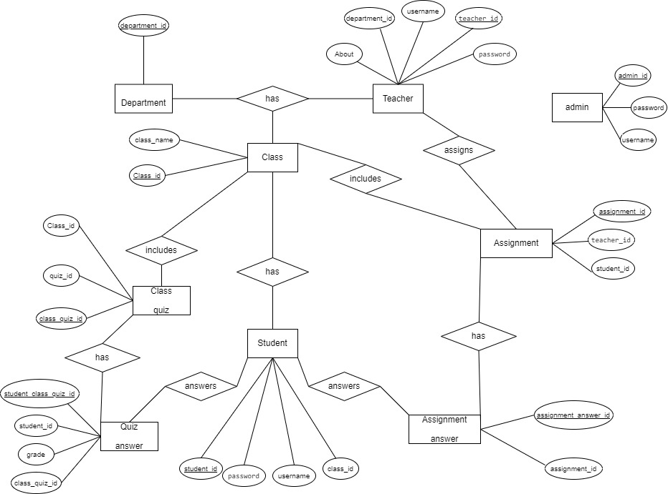

**Figure : E-R diagram for Online Education Website**

**Schema diagram :**

**Primary key:**

admin_id

teacher_id

student_id

assignment_id

student_assignment_id

class_id

department_id

class_quiz_id

**Foreign key :**

**Teacher:**

* + **department_id** (foreign key referencing **department.department_id**)

**Student:**

* + **class_id** (foreign key referencing **class.class_id**)

**Assignment Answer:**

* + **assignment_id** (foreign key referencing **assignment.assignment_id**)
  + **student_id** (foreign key referencing **student.student_id**)

**Assignment:**

* + **teacher_id** (foreign key referencing **teacher.teacher_id**)
  + **class_id** (foreign key referencing **class.class_id**)

**Class Quiz:**

* + **teacher_class_id** (foreign key referencing **class.class_id**)
  + **quiz_id** (foreign key referencing the relevant quiz table)

**Quiz Answer:**

* + **class_quiz_id** (foreign key referencing **class_quiz.class_quiz_id**)
  + **student_id** (foreign key referencing **student.student_id**)

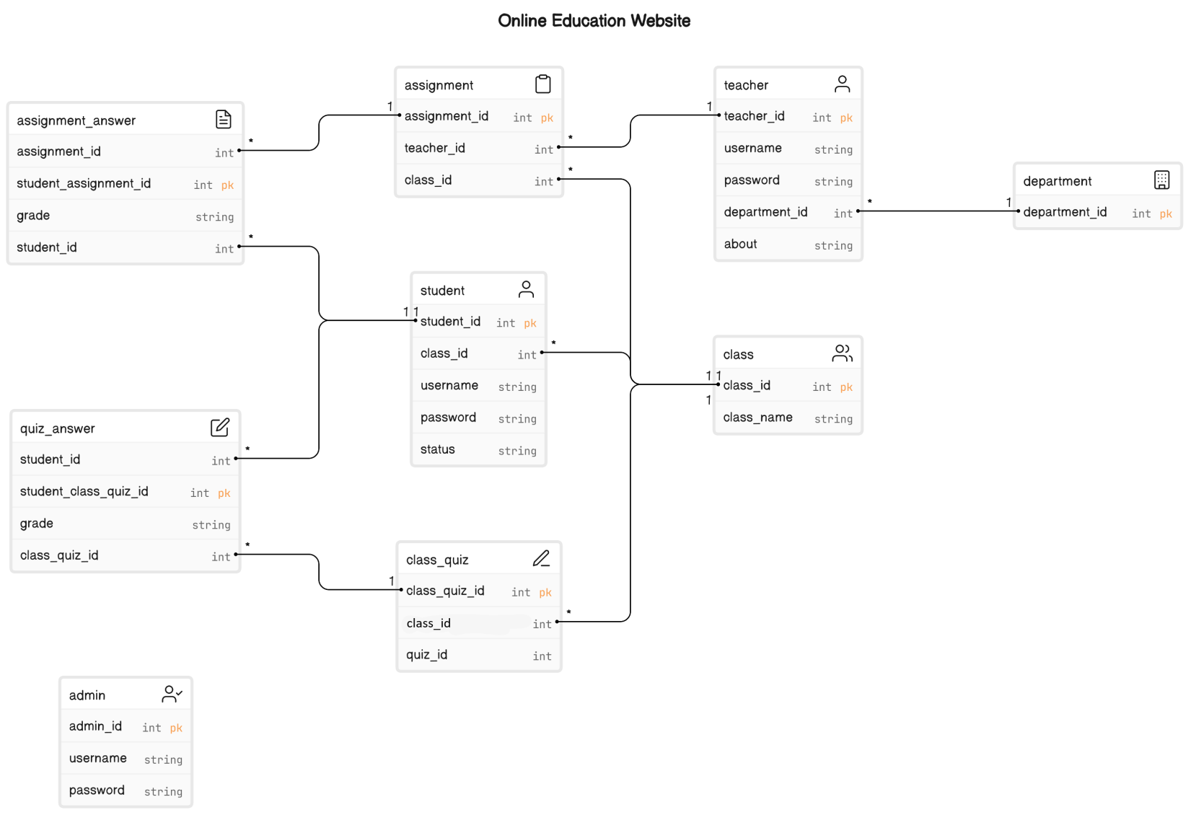

**Figure : Schema diagram for Online Education Website**

**Interaction diagram :**

The sequence diagram has mainly a login page under login page there are three user interaction (Admin Dashboard, Teachers’ homepage, Students’ homepage)

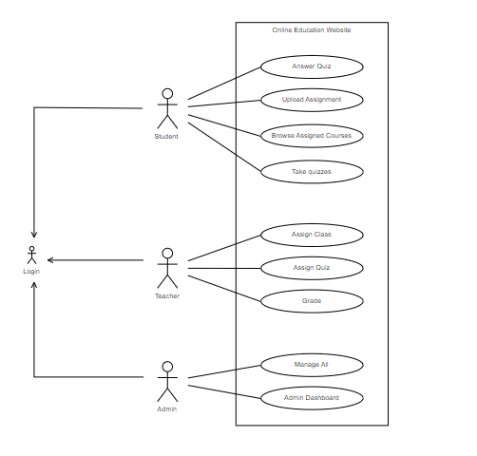

**Figure : Interaction diagram for Online Education Website**